SCIENCE FICTION FILMS

Choose a Science Fiction film and find examples of:

* Posters
* Trailer screen shots
* Merchandise
* DVD covers
* Website
* Any other promotion or marketing you can find

*See the one below for an example*

[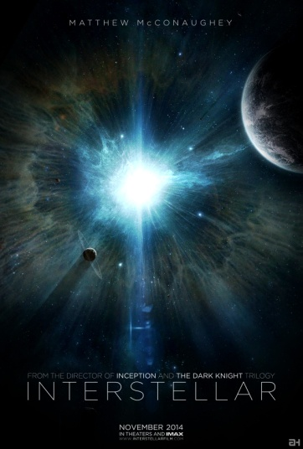](http://www.google.co.uk/url?sa=i&rct=j&q=interstellar+teaser+poster&source=images&cd=&cad=rja&uact=8&ved=0CAcQjRw&url=http%3A%2F%2Fwww.bms.co.in%2Fchristopher-nolans-interstellar-what-can-we-expect%2F&ei=jZSCVbyvEquv7AaUnICQDA&bvm=bv.96041959,d.ZGU&psig=AFQjCNHx3bI-fZ-a7e9yL0R_KTnLfDKDsg&ust=1434707444734174)[](http://www.google.co.uk/url?sa=i&rct=j&q=interstellar+release+poster&source=images&cd=&cad=rja&uact=8&ved=0CAcQjRw&url=http%3A%2F%2Fwww.hollywoodreporter.com%2Fheat-vision%2Finterstellar-has-gorgeous-posters-ever-734367&ei=uZSCVYPnLuPU7Ab-64OYCQ&bvm=bv.96041959,d.ZGU&psig=AFQjCNGUJMCl7LuOoUcyabvi88vdTASHRg&ust=1434707496771922)*[](http://www.google.co.uk/url?sa=i&rct=j&q=interstellar+promotional+tour&source=images&cd=&cad=rja&uact=8&ved=0CAcQjRw&url=http%3A%2F%2Fwww.celebitchy.com%2F396724%2Fanne_hathaway_on_a_solo_catwoman_film_i_would_be_totally_up_for_doing_it%2F&ei=nZWCVZbkIePO7gbgg4CYBw&bvm=bv.96041959,d.ZGU&psig=AFQjCNGSFrHYVO5eM2xaRtWdOvudQSCOtw&ust=1434707718042801)*[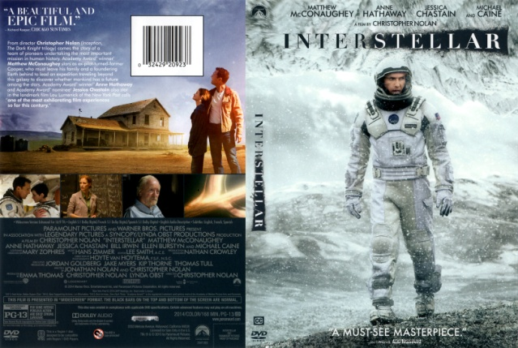](http://www.google.co.uk/url?sa=i&rct=j&q=interstellar+dvd&source=images&cd=&cad=rja&uact=8&ved=0CAcQjRw&url=http%3A%2F%2Fwww.freedvdcover.com%2Finterstellar-2014-r1%2F&ei=P5SCVZKELqLB7gaw94KABw&bvm=bv.96041959,d.ZGU&psig=AFQjCNEdOogXDF3a6y8XDrTxGmV-nnLAGg&ust=1434707388943736)*[](http://www.google.co.uk/url?sa=i&rct=j&q=interstellar+premiere&source=images&cd=&cad=rja&uact=8&ved=0CAcQjRw&url=http%3A%2F%2Fwww.filmandtvnow.com%2Finterstellar-premiere-footage%2F&ei=vpWCVZCJNqSE7gaR64GwBA&bvm=bv.96041959,d.ZGU&psig=AFQjCNFaAOKnTdiE10BIzeKmngekov1xnw&ust=1434707770955816)*

Red Carpet Premiere

DVD

Promotional tour

Release poster

Teaser poster

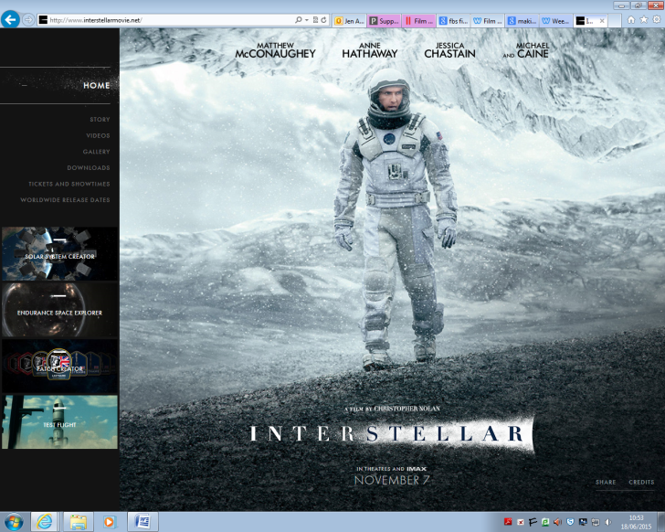 [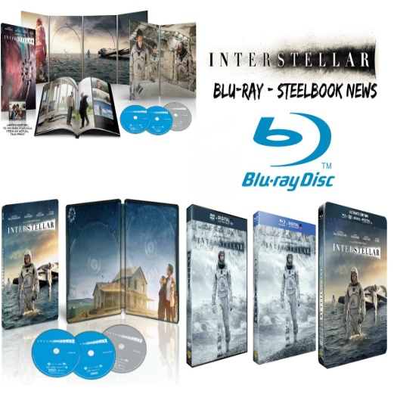](http://www.google.co.uk/url?sa=i&rct=j&q=interstellar+blu+ray&source=images&cd=&cad=rja&uact=8&ved=0CAcQjRw&url=http%3A%2F%2Fwww.youtube.com%2Fwatch%3Fv%3DKqcYX58PbFw&ei=YJSCVZWRCbGu7Aal1oPIBg&bvm=bv.96041959,d.ZGU&psig=AFQjCNFi_RBtMw4pX39s0TO-gQcnZRplkQ&ust=1434707413884373)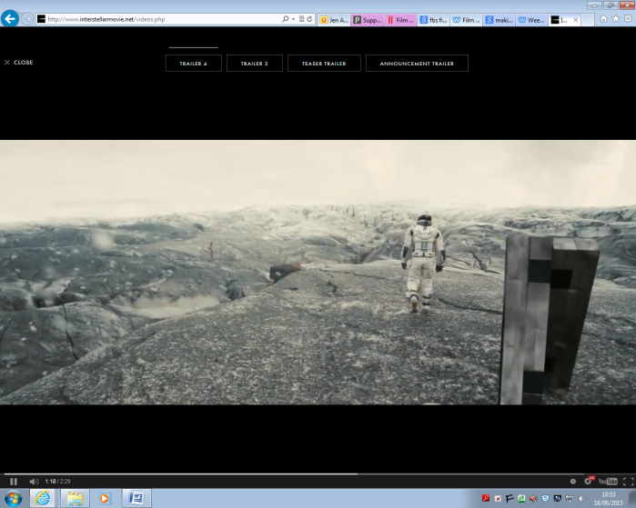[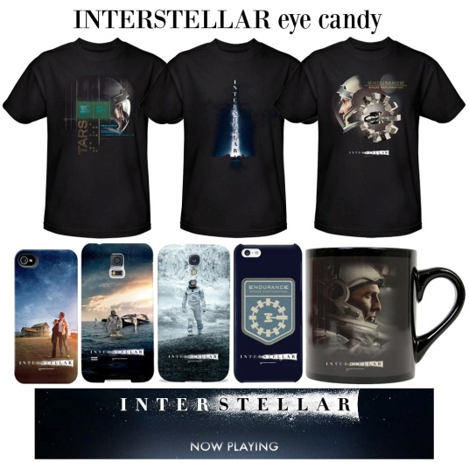](http://www.google.co.uk/url?sa=i&rct=j&q=interstellar+merchandise&source=images&cd=&cad=rja&uact=8&ved=0CAcQjRw&url=https%3A%2F%2Ftwitter.com%2Fwbshop%2Fstatus%2F531888045264351233&ei=aZWCVZiRF8OY7gbQ_IGADA&bvm=bv.96041959,d.ZGU&psig=AFQjCNGJQwcwACwvIEZkaJ8fZWbm85z4JA&ust=1434707681666416)

Trailers

Merchandise

Collectors Blu Ray

Website